**First Principles Modeling**

**Topics Covered**

• Obtaining the equations of motion of a DC motor based rotary servo.

• Creating and validating a system model.

• Model validation.

**Prerequisites**

• Integration laboratory experiment.

• Filtering laboratory experiment.

• Bump Test Modeling laboratory experiment.

**1 Background**

The Quanser QUBE-Servo 2 is a direct-drive rotary servo system. Its motor armature circuit schematic is shown in Figure 1.1 and the electrical and mechanical parameters are given in Table 1.1. The DC motor shaft is connected to the *load hub*. The hub is a metal disk used to mount the disk or rotary pendulum and has a moment of inertia of *Jh* . A disk load is attached to the output shaft with a moment of inertia of *Jd* .

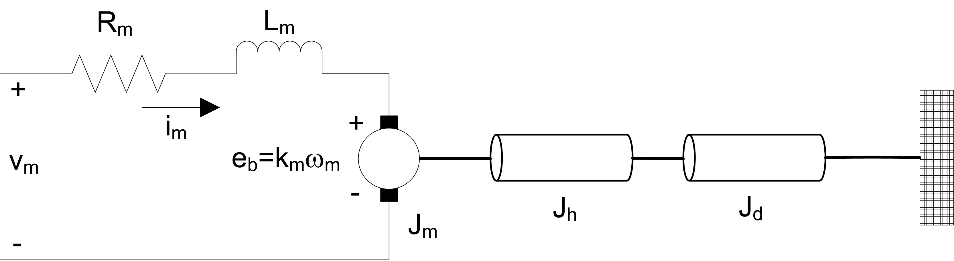

Figure 1.1: QUBE-Servo 2 DC motor and load

The back-emf (electromotive) voltage *eb* (*t*) depends on the speed of the motor shaft, *ωm* , and the back-emf constant of the motor, *km* . It opposes the current flow. The back emf voltage is given by:

*eb* (*t*) = *km ωm* (*t*) (1.1)

|  |  |  |
| --- | --- | --- |
| **Symbol** | **Description** | **Value** |
| **DC Motor** | | |
| *Rm* | Terminal resistance | 8*.*4Ω |
| *kt* | Torque constant | 0*.*042 N*.*m/A |
| *km* | Motor back-emf constant | 0*.*042 V/(rad/s) |
| *Jm* | Rotor inertia | 4*.*0 *×* 10*−*6 kg*.*m2 |
| *Lm* | Rotor inductance | 1*.*16 mH |
| **Load Hub** | | |
| *mh* | Load hub mass | 0*.*0106 kg |
| *rh* | Load hub radius | 0*.*0111 m |
| **Load Disk** | | |
| *md* | Load disk mass | 0*.*053 kg |
| *rd* | Load disk radius | 0*.*0248 m |

Table 1.1: QUBE-Servo 2 system parameters

Using Kirchoff’s Voltage Law, we can write the following equation:

*vm* (*t*) *− Rm im* (*t*) *− Lm*

*dim* (*t*)

*dt − km ωm* (*t*) = 0*.* (1.2)

Since the motor inductance *Lm* is much less than its resistance, it can be ignored. Then, the equation becomes

*vm* (*t*) *− Rm im* (*t*) *− km ωm* (*t*) = 0*.* (1.3)

Solving for *im* (*t*), the motor current can be found as:

*im* (*t*) =

*vm* (*t*) *− km ωm* (*t*)

*Rm*

*.* (1.4)

The motor shaft equation is expressed as

*Jeq ω*˙ *m* (*t*) = *τm* (*t*)*,* (1.5)

where *Jeq* is total moment of inertia acting on the motor shaft and *τm* is the applied torque from the DC motor. Based on the current applied, the torque is

*τm* = *kt im* (*t*)*.* (1.6)

The moment of inertia of a disk about its pivot, with mass *m* and radius *r* is

1

*J* = *mr*2 *.* (1.7)

2

**2 In-Lab Exercises**

Based on the VIs already designed in Integration and Filtering laboratory experiment, design a VI that applies a

1 *−* 3 V*,* 0*.*4 Hz square wave to the motor and reads the servo velocity using the encoder as shown in Figure 2.1.

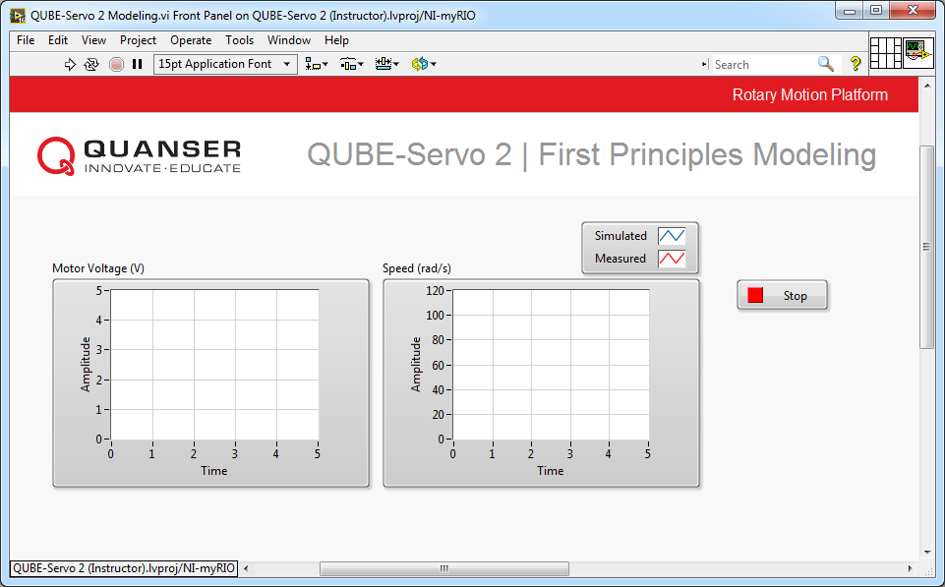

(a) Front Panel

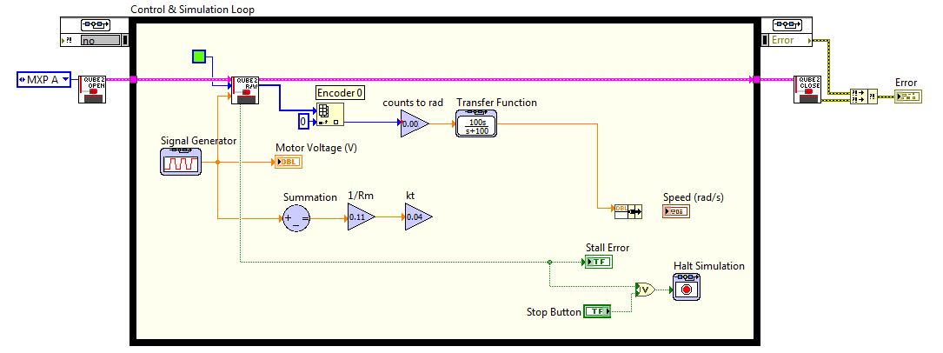

(b) Block Diagram

Figure 2.1: Applies a step voltage and displays measured and simulated QUBE-Servo 2 speed (incomplete block diagram)

Using the equations given above, assemble a simple block diagram in the block diagram of the VI to model the system. You’ll need a few Gain blocks, a Subtract block, and an Integrator block (to go from acceleration to speed). Part of the solution is shown in the block diagram in Figure 2.1.

1. The motor shaft of the QUBE-Servo 2 is attached to a *load hub* and a disk load. Based on the parameters given in Table 1.1, calculate the equivalent moment of inertia that is acting on the motor shaft.

2. Design the QUBE-Servo 2 model using *Control & Simulation* blocks as described above. Attach a screen capture of your model.

3. Run the VI with your QUBE-Servo 2 model. The waveform chart response should be similar to Figure 2.2.

Attach a screen capture of your waveform charts. Does your model represent the QUBE-Servo 2 well? Explain.

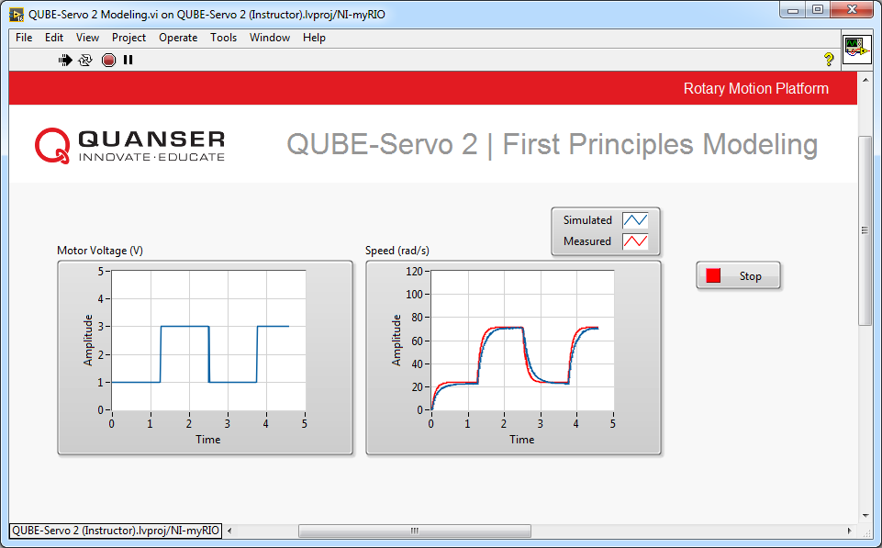

Figure 2.2: QUBE-Servo 2 Measured and Simulated Responses

4. Formulate the differential equation for *ωm* using Equation 1.4 to Equation 1.6. Compare your result with the transfer function obtained from the Bump Test Modeling laboratory experiment. (**Hint:** Obtain the Voltage *Vm* (*s*) to Speed Ω*m* (*s*) transfer function by applying a Laplace Transform to the derived differential equation.)

5. Click on the Stop button to stop the VI.

© 2017 Quanser Inc., All rights reserved.

Quanser Inc.

119 Spy Court Markham, Ontario L3R 5H6

Canada [info@quanser.com](mailto:info@quanser.com) Phone: 1-905-940-3575

Fax: 1-905-940-3576

Printed in Markham, Ontario.

For more information on the solutions Quanser Inc. offers, please visit the web site at:

[http://www.quanser.com](http://www.quanser.com/)

This document and the software described in it are provided subject to a license agreement. Neither the software nor this document may be used or copied except as specified under the terms of that license agreement. Quanser Inc. grants the following rights: a) The right to reproduce the work, to incorporate the work into one or more collections, and to reproduce the work as incorporated in the collections, b) to create and reproduce adaptations provided reasonable steps are taken to clearly identify the changes that were made to the original work, c) to distribute and publically perform the work including as incorporated in collections, and d) to distribute and publicly perform adaptations. The above rights may be exercised in all media and formats whether now known or hereafter devised. These rights are granted subject to and limited by the following restrictions: a) You may not exercise any of the rights granted to You in above in any manner that is primarily intended for or directed toward commercial advantage or private monetary compensation, and b) You must keep intact all copyright notices for the Work and provide the name Quanser Inc. for attribution. These restrictions may not be waved without express prior written permission of Quanser Inc.